FULL SUBTRACTOR

AIM: To implement the fullsubtractor using logic sim.

INPUT:

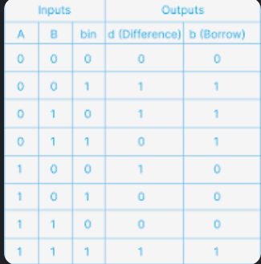

OUTPUT:

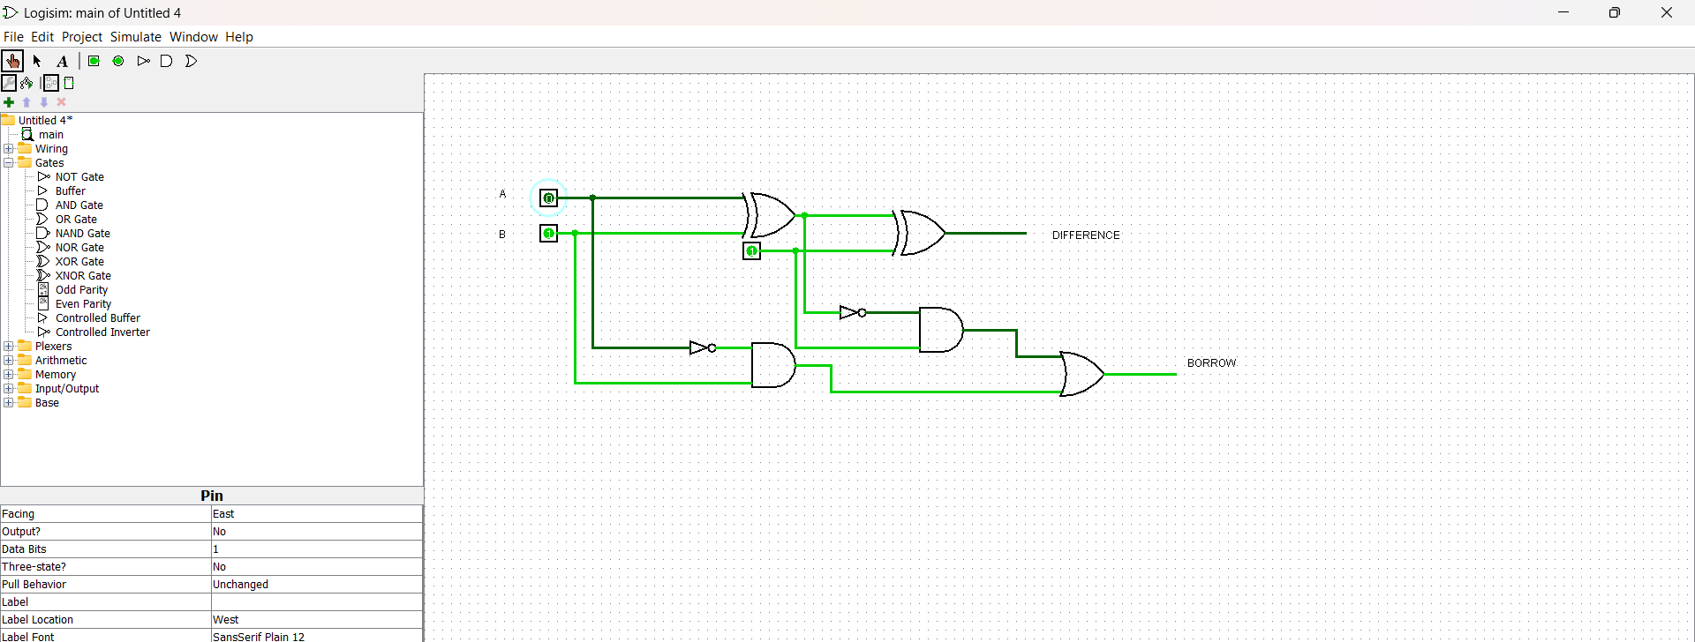

RESULT: Thus the program was executed successfully using logic sim.